12. Narrative Statement

The Masters of Science degree offered through the University of New Hampshire (UNH) Department of Natural Resources requires (1) no less than 30 credit hours of course work including 3 required courses (NR 993, Seminar, NR 903, Approach to Research—a quantitative methods course and NR 996, Natural Resource Education), and (2) a directed research project (NR 998, Directed Research) or thesis ( NR 899, Thesis and formal presentation of thesis or directed research results) and a formal presentation of the thesis or directed research results. The program offers students independence to develop their proposed research topic and course of study.

Through the Natural Resources M.S. degree program at the University of New Hampshire I plan to pursue my career interests in the area of temperate forest ecology. I plan to develop my research focus, proposed thesis and field work in an interdisciplinary manner, encompassing a range of course work at UNH including forest biometrics, plant biology, terrestrial ecology, and quantitative ecology. As a thesis project I have the opportunity to undertake an analysis of long-term forest growth and productivity data from the Bartlett Experimental Forest (BEF), NH on which I was the data collection crew leader for the most recent inventory.

The goals of this project will be to (1) use observations of tree dynamics (growth and mortality) from a 70+ year temporal record of 444 permanent forest inventory plots from the USDA Forest Service Bartlett Experimental Forest, NH to explore trends in biomass accumulation over time in both managed and unmanaged stands; and, (2) using historical records from the regional forestry and ecology literature, to document and compare records of standing biomass (and volume converted to biomass) of young, mature and old-growth forests over time with that derived from the BEF chronosequence, thus providing a view of the range in natural variance in long-term biomass accumulation for northern hardwood forests of the region.

Forest ecosystems, particularly northern temperate forests, play a critical role in the Earth’s carbon budget (Myneni et al, 2001 Caspersen et al. 2000, Potter et al. 2003). Temperate forests average from twice to 20 times higher productivity than desert, grassland, or shrub-land vegetation, and store up to several orders of magnitude more carbon above ground than do these other vegetation types (Curtis et al. 2002), yet current detailed understanding of forest ecosystem level production is often limited to small areas and short (decadal or less) time spans (e.g. Barford et al. 2001, Curtis et al. 2002, Scurlock and Olsen 1999). To understand the role of forests in the global carbon cycle, it is necessary to understand the dynamics of biomass accumulation and the patterns of change through time resulting from both natural dynamics and human management. Detailed and accurate estimates of forest productivity are critically needed to constrain and evaluate models of carbon uptake (Hibbard and Sahagian 1998), as well as to evaluate new regional- to continental-scale remote sensing based estimates of forest productivity, such as those currently being produced by the EOS Terra sensor (Justice et al. 2000). At local to regional scales, understanding of the range in natural variability in forest productivity over time is needed to inform such concepts as sustainable land management and preservation of long-term forest productivity (NFMA 1976, Cardoch et al. 2002).
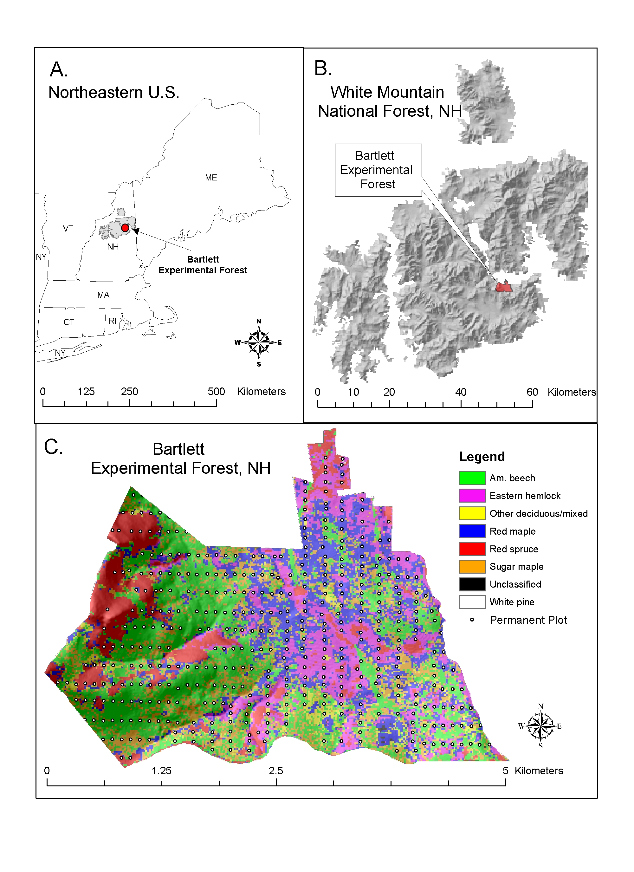
The BEF dataset is unique in that it is a true chronosequence of forest growth, representing 70+ years of change in both managed and unmanaged stands for a >1000 ha landscape in the heavily forested White Mountain region of New Hampshire (Figure 1a, b). The inventory chronosquence derives from a network of 500 permanent plots, established in 1932 by the USDA Forest Service Northeastern Research Station, of which 444 remain (Fig. 1c). The square 0.1 ha (1/4 acre) plots are spaced 200 m by 100 m apart in a regular grid. Re-measurement of all trees > 2 inches diameter at breast height (DBH) on a majority of these plots was completed in 1931-32, 1939-40, 1991-92 and 2001-2003, with partial re-measurements completed in the 1950’s and 1960’s. Some plots are in managed compartments that receive silvicultural treatments; others are in areas that are not entered for harvest. An additional and unique feature of these data is that stand ages for all plots were assessed quantitatively in 1930. Even-aged stands—approximately 200 plots, arising from severe stand replacing disturbances, mostly cutting, in the mid to late 1800’s— were classified in 20 year intervals up to stand ages of 100-120 years. Remaining plots were classified as all-aged with tree age distributions varying upward of 150 years. Since 1930, detailed records on stand replacing disturbances (cutting, hurricane damage, etc.) have been maintained giving a comprehensive picture of the dynamics of change in standing biomass with age and disturbance over time.
Figure 1. Location of the Bartlett Experimental Forest (BEF) within (a) the larger northeastern U.S. region and (b) the White Mountain National Forest, NH; (c) permanent inventory plot distribution in relation to species composition and topographic relief at the BEF.

All forest inventories at BEF consist of measurements of DBH, recorded in 1 inch size classes, for all species > 2 inches DBH on each plot. These data will be converted to above ground wood biomass using allometric equations for species of this region. In most forest ecosystems, aboveground biomass and its increments are strongly dominated by the overstory trees (Clark et.al 2001). Wood production (bole + branch) will be the focus of calculations for the BEF and similar data from the regional literature because many more independent data are available for wood growth, biomass, and/or volume than for other components of productivity (foliar production, root production, etc.), and because allometric estimators of aboveground wood biomass (using standard forestry measures such as DBH) developed for forest types of this region are very good (Arthur et al. 2001). Inventories completed in 1992 and 2003 explicitly account for tree mortality for stems ≥ 5 inches, which will allow for direct estimates of both growth and mortality for this time period as well as standing biomass. Clark et al (2001) note that it is the failure to account for tree mortality and in-growth that most often results in underestimates of aboveground biomass production.

These data will be a starting point to examine trends in northern hardwood forest standing live biomass and biomass accumulation with age over time, using data from both BEF and data that can be found in the literature from the region. The stand age of most plots at BEF is known, based on starting point estimates in 1930. Working forward from these estimates and keeping track of inventories after significant disturbances (e.g. 1938 hurricane) and stand changing silvicultural treatments, a reasonable estimate of change in biomass with age over time may be constructed, and variance around average standing biomass with age may also be derived. Literature data will be used as additional observations of biomass with age and compared with the BEF chronosequence, yielding a picture of the range in variability in standing biomass with age for forests of this region over the last century. Direct estimates of forest productivity (accounting for both ingrowth and mortality) as well as standing biomass will be calculated based on the 1992 and 2003 inventories. These data can be used to address such questions as: (1) How do rates of biomass accumulation change with time in northern hardwood forests? (2) How do observed rates of change in biomass accumulation with age compare to stand development theory (e.g Bormann and Likens 1981)?

When completed this analysis will provide a more than 100 year chronosquence of actual biomass accumulation in northern hardwood forests of the northeastern U.S., a region of North America believed to have a large capacity for carbon uptake and storage. To my knowledge no such other long-term data at such high spatial and temporal resolution exists for any forest system in this region. These data will be made available to the research community through journal publication and through established data archives (such as that provided by the Ecological Society of America). At the Bartlett Forest these data will also be used in evaluation of estimates of carbon uptake and exchange as derived from a recently established eddy covariance flux measurement tower, and will also be used in evaluation of remote sensing based estimates of forest biomass and productivity derived from multi-spectral, hyperspectral, and LIDAR instruments (e.g. Smith et al 2002, Smith et al. 2003).

Literature Cited

Arthur, M. A., Hamburg, S. P., and Siccama, T. G., 2001. Validating allometric estimates of aboveground living biomass and nutrient contents of a northern hardwood forest. Canadian Journal of Forest Research 31: 11-17.
Barford, C.C., Wofsy S.C., Goulden, M.L., Munger, W.J., Pyle, E.H., Urbanski, S.P., Hutyra, L., Saleska, S. R., Fitsjarrald, D., Moore, K., 2001. Factors Controlling Long-and Short-Term Sequestration of Atmospheric CO₂ in a Mid-Latitude Forest. Science 294: 1688-1691
Clark D.A., Brown S., Kicklighter D.W., Chambers J.W., Thomlinson J.R., Ni J. 2001. Measuring net primary production in forests: concepts and field methods. Ecological Applications, 11: 356-370.
Caspersen, J.P., Paccala, J.W.,Jenkins, J.C., Hurtt, G.C., Moorcroft, P.R., Birdsey, R.A., 2000. Contributions of land-use history to carbon accumulation in U.S. forests. Science 290: 1148-1151.
Cardoch L., Day J.W., Ibanez C. 2002. Net primary productivity as an indicator of sustainability in the Ebro and Mississippi deltas. Ecological Applications. 12 (4): 1044-1055.
Curtis, P.S., Hanson, P.J., Bolstad, P., Bradford, C., Randolph, J.C., Schmid, H.P., Wilson, K.B., 2002. Biometric and eddy-covariance based estimates of annual carbon storage in five eatern North American deciduous forests. Agricultural and Forest Meteorology 113. 3-19
Hibbard, K., and Sahagian, D. (Editors). 1998. Net primary productivity model intercomparison activity. IGBP/GAIM Report #5. University of New Hampshire, Durham, N.H., U.S.A., 41 p.
Justice, C., Belward, A., Morisette, J., Lewis, P., Privette, J., and Baret, F., 2000, Developments in the 'validation' of satellite sensor products for the study of the land surface. International Journal of Remote Sensing, 21, 3383-3390.
Myneni, R.B., Dong, J., Tucker, C.J., Kaufmann, R.K., Kauppi, P.E., Liski, J., Zhou, L., Alexeyev, V., Hughes, M.K., 2001. A large carbon sink in the woody biomass of Northern forests. Proceedings of the National Academy of Sciences 98 (26): 14784-14789.
NFMA 1976. National Forest Management Act of 1976. 16 U.S.C. 1600 (1994 & Supp. III 1997)
Potter, C., Klooster, S., Myneni, R., Genovese, V., Tan, P.N., Kumar, V., 2003.Continental-scale comparisons of terrestrial carbon sinks estimated from satellite data and ecosystem modeling 1982-1998. Global and Planetary Change 39: 201-213.
Scurlock, J.M.O., Olson, R.J.,2002. Terrestrial net primary productivity—A brief history and a new worldwide database. Environmental Review 10: 91-109.
Smith, M.L., Ollinger, S.V., Martin, M.E., Aber, J.D., Hallett, R.A., Goodale, C.L., 2002. Direct estimation of forest productivity through hyperspectral remote sensing of canopy nitrogen. Ecological Applications 12 (5): 1286-1302.
Smith, M.L., Martin, M.E., Ollinger, S.V., Plourde, L., 2003. Analysis of hyperspectral data for estimation of temperate forest canopy nitrogen concentration: comparison between an airborne (AVIRIS) and a spaceborne (HYPERION) sensor. IEEE Transactions on Geosciences and Remote Sensing, 41(6): 1332-1337.

