How do scientists measure trees? What is DBH?

Purpose
- Students develop an understanding of tree size and how scientists measure trees. Students observe and measure tree cookies and explore the relationship between tree circumference and diameter.
- Students compare the estimates of diameter made from circumference measurements (and vice versa).

Overview
In this activity students will observe and explore the relationship between circumference and diameter using tree cookies (cross sections from real trees).

Essential Questions
How do scientists measure trees?
Sub-questions
What is the relationship between circumference and diameter?
What is diameter-at-breast-height?

Student Outcomes
- Students will observe the physical characteristics of and suggest ways to measure tree cookies (i.e., cross sections of real trees).
- Students will work with a partner to measure the circumference and diameter of one tree cookie.
- Students will work with a partner to calculate circumference or diameter of the tree cookie based on the circle equation. Students will compare and contrast the calculated circumference and diameter values to the actual measurements of these parameters.

Science Concepts
5-8 & 9-12
Change, constancy, measurement
Abilities necessary to do scientific inquiry

Time
60 - 90 minutes

Level
Middle & High School

Materials and Tools
- Several different sized tree cookies (1 per student pair)
- Flexible measuring tape (metric) (1 per student pair)
- Calculator (1 per student pair)
- Notebook and pencil (1 per student)
- Items for circumference height tool [Optional]
  - Sticks and permanent marker OR Strings and scissors (see part 2)

Preparation
Write the main essential question on the board. Gather all materials for the activity.

Pre-requisites
Skill: Calculating average (mean) numbers

Background

Scientists use a standard method to measure the size of trees, diameter-at-breast height (DBH), to ensure consistency over time, across plots and between data collectors. DBH means the diameter of each tree is measured at “breast height”, defined as 1.35m up from the highest point of ground at the tree’s base (See the Tree Circumference Guide for some pictorial examples). DBH measurements can be used to estimate the volume, biomass, and carbon storage of trees - to learn more about the relationship between DBH and biomass refer to the activity, Understanding Allometry. Keep in mind that circumference and DBH are the first two steps in the process of understanding biomass and carbon storage in local ecosystems.

From geometry class, we know that diameter is a line that passes through the center of a circle, with the endpoints of the line located on the edge of the circle. How then can foresters and scientists measure tree diameter without cutting down the tree and measuring its cross section? Scientists measure the circumference of a tree and calculate the diameter using equation 1 shown below. Scientists sometimes use tape measures that are calibrated or adjusted for diameter based on this equation. These tapes are referred to as DBH tapes. During the GLOBE Carbon Cycle field data collection, however, students will measure tree circumference rather than diameter (due to tool restrictions); therefore it is important for them to know how circumference and diameter are related.

Circumference = π*diameter (where π = 3.14) or Diameter = Circumference/ π [equation 1]

Field Concepts Diagram

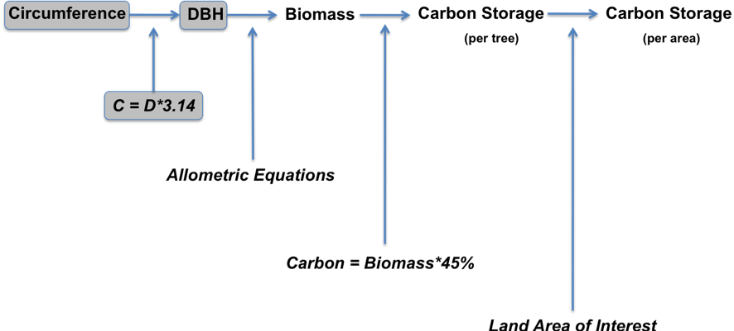

What To Do and How To Do It

ENGAGE | Student Grouping: Partners (Part 1) | Time: 5 minutes
ENGAGE | - In groups of two, students select a tree cookie and complete Part 1a of the Student Directions.  - Class discussion of student’s observations and suggestions for tree cookie measurement.  - Introduce the essential question, equation 1, and set the expectations for Part 2.  - Demonstrate to measure the circumference and diameter of a tree cookie.  - Remind students how to calculate an average if necessary.
 | Student Grouping: Partners (Part 2) | Time: 20 minutes
EXPLORE | - Students conduct measurements and calculations as directed on the student sheet. This is a proof of concept exercise to show students how diameter and circumference are related.
EXPLAIN | Student Grouping: Whole Class | Time: 15 minutes
EXPLAIN | - Interpret the measurements and discuss answers student questions #5a-c.  - Use question 5c as a lead in to the next part of the activity: How might scientists (and you) use the circumference/diameter relationship to study live trees?  - Discuss the standard height at which circumference (diameter) is measured, 1.35m, called diameter-at-breast-height (DBH).  - Students create a tool for measuring that height in the field.  - Ahead of time you should select the method students should use.  - This is a good point to have a discussion about accuracy and precision. You may want to brainstorm some ideas about what those terms mean before students read about them in Student Directions: Part 3.
ELABORATE/ INVESTIGATE | Student Grouping: Partners (Part 3) | Time: 30 minutes
ELABORATE/ INVESTIGATE | - Students determine the height of 1.35m against their own body.  - Students follow teacher directions to create a height measurement tool. [Optional]  - Use a measuring tape or meter stick, measure out 1.35m:  - on a stick and mark with a permanent marker  OR  - on a string and cut the string so it is exactly 1.35m tall  - Students perform activities to investigate accuracy and precision.
EVALUATE/WRAP-UP | Student Grouping: Whole Class | Time: 10 minutes
EVALUATE/WRAP-UP | - Introduce the Field Concepts Diagram and highlight the first step, which this activity supports.  **See activity example in HowToMeasureTrees_example.xls

Assessment
- Students should answer the essential question individually and explain the connection between this activity and the upcoming field work.
Name: Date:

Student Directions: How do scientists measure trees? What is DBH?

Part 1: Tree Cookie Observations
- Record the physical traits of your selected tree cookie. Draw and/or describe.

- Suggest some ways that your tree cookie could be measured to learn about its size.

Essential Question: How do scientists measure trees?

Part 2: Circumference versus Diameter
- Measure 1 tree cookie per group.
  - Pull the measuring tape tightly around the tree cookie and record its circumference in the data table below. Sharing measurement responsibilities between group members, repeat the circumference measurement 2 more times on the same tree cookie.

  - Measure the tree cookie’s diameter and record in the data table. Repeat the diameter measurement 2 more times. Note: Measure the diameter in several directions across the surface of the tree cookie, as they will not be perfectly round and you want to make sure your measurements represent the overall shape of the tree cookie.

 | Circumference | Diameter
Trial 1
Trial 2
Trial 3
Average
(1+2+3)/3

- Calculate an average (mean) circumference and average (mean) diameter for the tree cookie.

Average (mean) = Sum all of the values ÷ by the # of values. [Equation 1]

- Use equations 2 & 3 and the appropriate calculated averages (of circumference and diameter) to find a calculated circumference and diameter.

Calculated Circumference = π*average diameter (where π = 3.14) [Equation 2]
Calculated Diameter = average circumference/ π [Equation 3]

 | Circumference | Diameter
Calculated
(using equation 1)

- Compare calculations to averages by answering the following questions:

  - How similar are your measured circumference values?

  - How similar are your measured diameter values?

  - Why might calculated values be different from measured average values?

  - How might scientists (and you) use the circumference/diameter relationship to study live trees?

- Discuss Part 2 as a class.

Part 3: Prepare to measure tree circumference in the field.

- How high is 1.35m?

  - Measure 1.35m from the ground and determine where this falls on your body (nose/neck/shoulder/etc) as a basic reference. This reference point will be used when making field measurements. By standing near a tree, and using this reference point, you will not have to measure from the ground at each tree to determine the 1.35m height.

  - Follow you’re your teacher’s instructions for how to create a height measurement tool.

- Measuring trees greater than 15 centimeters circumference.

  - When measuring trees in the field you will only record information for trees greater than or equal to 15cm circumference. While this value may seem arbitrary it is equal to 2 inches diameter, a cutoff used by scientists in many other forest inventory programs. A cutoff value is used for several reasons:
    - It is not practical to measure every small sapling on a sample site,
    - In a forest, saplings do not contribute a significant amount of biomass,
    - Many saplings smaller than 15cm die off due to lack of available light.

In some forest inventories saplings are counted separately on a sub-plot, however, since we are only trying to assess basic carbon storage we will not include saplings in our study.

- Two key concepts scientists must consider when they measure trees in the field, are accuracy and precision.

  - Accuracy: Accuracy is the degree to which a measured or calculated value matches the true value. In the case of circumference measurements this can be influenced by:
    - Placement of the measuring tape: Is the measurement 1.35m from the ground? Was the tape perpendicular to the main axis of the tree? Was the tape twisted?
    - Reading and recording data: Was the correct number read from the tape? Was this number correctly entered on the datasheet?

By closely following the rules in the Tree Circumference Guide, and carefully recording data, one will be able to make accurate circumference measurements. Accuracy becomes particularly important if trees are measured in future years and compared to previous measurements.

  - Precision: Precision is the degree to which repeated measurements of the same tree are in agreement. You can determine how precise circumference can be measured by making repeated measurements of the same tree – either by one person, or by several people.

    - With your group, re-examine your tree cookie circumference results from Part 2. How precise were your measurements?

    - Why might they be different? How tight did you pull the tape to read the measurement? What decimal place did they record to? Was the measuring tape flat or twisted as it was pulled around cookie? How many measurements do you think should be made in order to know if you have a precise measurement? Why?

  - Make a list of at least 4 things you can do in the field to make sure all of your measurements are made accurately and precisely?

Tree Circumference Guide

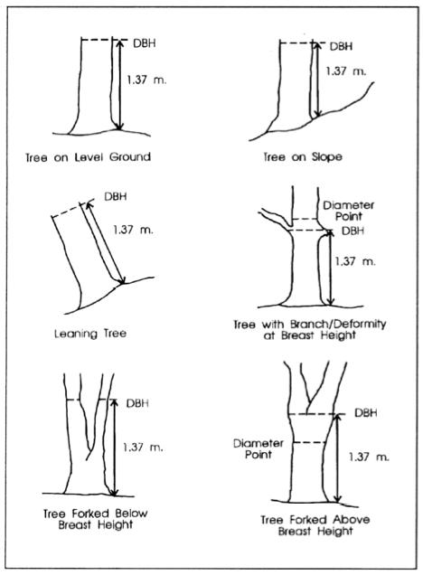
GLOBE Carbon Cycle Tree Circumference Protocol adapted from USDA Forest Service DBH Protocol
1.35m
1.35m
1.35m
1.35m
1.35m
1.35m
Circumference
Circumference
Circumference
Circumference
Circumference
Circumference
Measure Here
Measure Here

