How to Use a Compass
(Adapted from the Wisconsin Department of Natural Resources Explorer Program and Environmental Education for Kids)
A compass is useful for many applications. Used with a map, a compass can help you find your way across the landscape. In the case of GLOBE field investigations the compass will be used to set up field plots that can be measured and returned to every year.
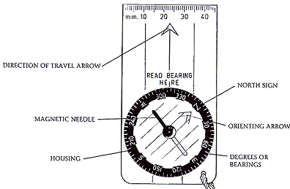
Investigating a Compass
BASE PLATE
DEGREES OR AZIMUTH

- Review the parts of the compass.
- Examine the degrees noted on the housing of your compass. Degrees can be in different increments, typically 2° or 5°.
- Hold the compass flat in the palm of your hand with the direction of travel arrow pointed away from you.
- Practice turning the housing.
- The red part of the magnetic needle naturally points toward Earth’s magnetic north pole. (For more information on magnetic versus true north see GLOBE: GPS Investigation: Compass: True North.)
- Move around the area, and watch how the magnetic needle always points the same direction.
  - It doesn’t always point in the same direction? Is there any metal around? Jacket zippers, keys, field tools, desks, cars – How do these objects effect the magnetic needle?

Using a Compass

Goal 1: Face North
- Hold your compass in front of you, turn the housing dial until the N is lined up with the direction of travel arrow – where it says, “Read bearing here”.
- Now turn your body, NOT YOUR COMPASS, until the red part of the magnetic needle is inside of the orienting arrow. A catchy way to remember this is – Red in the Shed
- You are now facing north.
- Practice again using E (90°)
Goal 2: Which direction are you facing?
- Turn your body to face a direction of your choice.
- Turn the housing until Red is in the Shed.
- Read the degrees (azimuth) that is lined up with the direction of travel arrow – this is the direction you are facing.
- Practice again facing a new direction.
Goal 3: Find the azimuth of an object
- Select a nearby object and turn to face it, holding the compass in front of you.
- Turn the housing until Red is in the Shed.
- Read the azimuth – this is the direction to the object from where you are standing.
Goal 4: Pace on an azimuth
- Turn your housing to the desired azimuth.
- Turn your body until Red is in the Shed.
- Choose an object that is in line with your azimuth and pace toward it. This allows you to walk without looking down at your compass.
- When you reach the object, select another object on the same azimuth and continue pacing.

