Tier 3 Auxiliary Data Catalog

The Tier 3 Auxiliary Data Catalog is an attempt to create an inventory of all datasets in addition to the biometric data collected at each Tier 3 site. The data catalog contains basic information about the dataset including contact information where further details may be obtained. The data catalog was created in a relational database so that all data types can easily be queried simultaneously.

Since the referential integrity is assigned between all tables (Figure 1), the site information must be competed before entering information into the REMOTE_SENSING, MODELED and AUXILIARY tables. The SITE and MAILING information only needs to be entered once for each site.

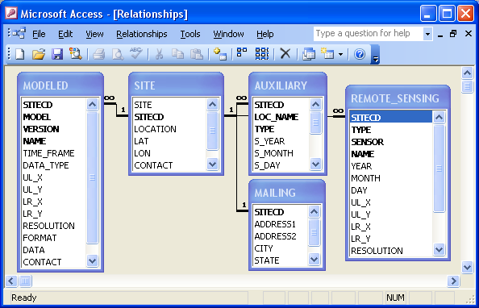
Figure 1. Tables, relationships and referential integrity for the Tier 3 Auxiliary Data Catalog.

The SITECD column is used to create the relationships between each table and must be entered in identically so the relationships are maintained and the data can be saved. The variable names and descriptions for each table are listed below. The variable descriptions can also be found in the relational database by opening the tables in design view. All variables identified as a primary key (bold text in variables listed below) must have a value entered for a new entry to be saved.

SITE – General site information

Variable Name | Variable Description
SITE | Name of the site
SITECD | Site abbreviation code (e.g. Silas Little = SL)
LOCATION | General location
LAT | Latitude of site (WGS84 - decimal degrees, 6 - decimal places)
LON | Longitude of site (WGS84 - decimal degrees, 6 - decimal places)
CONTACT | Site contact name
EMAIL | Site managers email

MAILING - Site mailing address

Variable Name | Variable Description
SITECD | Site abbreviation code (e.g. Silas Little = SL)
ADDRESS1 | Address 1 of the site
ADDRESS2 | Address 2 of the site
CITY | City where the site is located
STATE | State where the site is located
ZIP | Zip code of the site

MODELED – Datasets derived from computer simulations

Variable Name | Variable Description
SITECD | Site abbreviation code (e.g. Silas Little = SL)
MODEL | Name of the model
VERSION | Model version
NAME | File name
TIME_FRAME | Time frame of the model output (1930 - 1955)
DATA_TYPE | Data type (Raster or Polygon)
UL_X | Longitude of upper left corner (WGS84 - decimal degrees, 6 - decimal places)
UL_Y | Latitude of upper left corner (WGS84 - decimal degrees, 6 - decimal places)
LR_X | Longitude of lower right corner (WGS84 - decimal degrees, 6 - decimal places)
LR_Y | Latitude of lower right corner (WGS84 - decimal degrees, 6 - decimal places)
RESOLUTION | Raster cell size
FORMAT | File format
DATA | Link to data if provided on another webpage (if not leave null)
CONTACT | Contact name
EMAIL | Contact email

REMOTE_SENSING – Datasets acquired from a sensor not in direct contact with the object

Variable Name | Variable Description
SITECD | Site abbreviation code (e.g. Silas Little = SL)
TYPE | Type of data (LIDAR, Hyperion, Landsat)
SENSOR | Name of the sensor (Quickbird)
NAME | File name
YEAR | Year of collection
DOY | Collection day of year
UL_X | Longitude of upper left corner (WGS84 - decimal degrees, 6 - decimal places)
UL_Y | Latitude of upper left corner (WGS84 - decimal degrees, 6 - decimal places)
LR_X | Longitude of lower right corner (WGS84 - decimal degrees, 6 - decimal places)
LR_Y | Latitude of lower right corner (WGS84 - decimal degrees, 6 - decimal places)
RESOLUTION | Raster cell size
FORMAT | File format
DATA | Link to data if provided on another webpage (if not leave null)
CONTACT | Contact name
EMAIL | Contact email

AUXILIARY – Any datasets in addition to the REMOTE SENSING and MODELED collected at the site

Variable Name | Variable Description
SITECD | Site abbreviation code (e.g. Silas Little = SL)
LOC_NAME | Name of location within the site (use site name if only one)
TYPE | Type of data (Eddy Flux, Micromet)
S_YEAR | Start year of data collection (if one time data collection enter year here)
S_MONTH | Start month of data collection (if one time data collection enter month here)
S_DAY | Start day of data collection (if one time data collection enter day here)
E_YEAR | End year of data collection (leave null if still collecting)
E_MONTH | End month of data collection (leave null if still collecting)
CONTACT | Contact name
EMAIL | Contact email

